Assignment 2

**Part 1:** make 5 partitions in your pendrive as: first 3 primary partitions(10MB each) then an extended one (think

yourself about it's size) last 2 partitions should be logical (50MB each) format them with ext4 filesystem mount the partitions on directory /mount1, /mount2, /mount3, /mount4, /mount5 validate the same by making files in the the above directories and then un-mount the same and then check if you still see the content in the directories

**Part 2:** Delete all the partitions that you created above and make a single partition of the size that pendrive is

of: make it an lvm partition make a physical volume create a volume group of same size as that of physical volume make an lvm of size 1GB extend the size to 1.5GB reduce the size to 500MB

Part 1:

Enter Command mode: fdisk /dev/sda

p :- is used to print partition table of disk we selected in command mode.

n :- is used to create partitioncd

after it we get two options, use

l : to create logical partition and

p : to create primary partition

After giving response it we have to specify sector of the disk we want the partition to start at. By default system will give you available sector as it is aware of other partitions. Just press ENTER to go with default.

After it provide partition number and size to it. (Example: +10M for 10 MB and +1G for 1 GB).

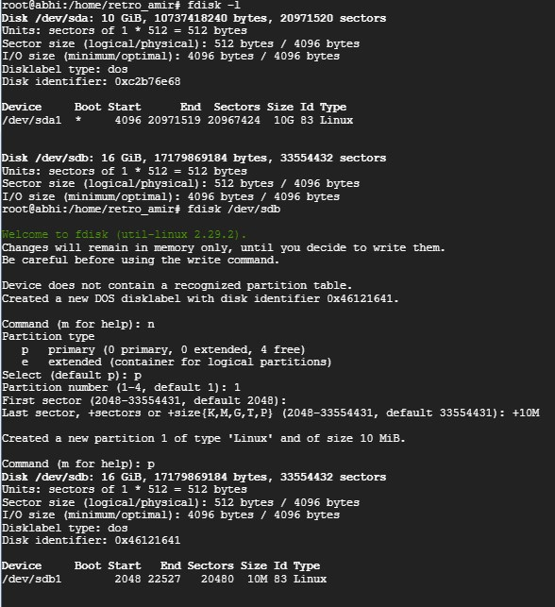

Use w to write the changes you’ve made to disk.

Similarly create all 6 partitions

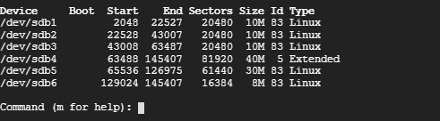

**Format them:**

mkfs.ext4 /dev/sda1

mkfs.ext4 /dev/sda2

------ so on

Extended volume cannot be formatted or mounted as it is just a container for logical partitions

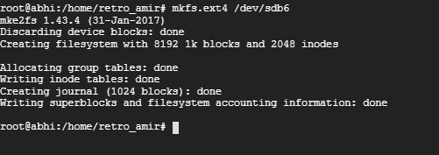

Mount them:

Mount sdb1,2…. To mount 1,2… directories correspondingly present in /mnt dir.

sudo mount -t auto -v /dev/sdb1 /mnt/mount_name

As we are using ext4 we will use

sudo mount -t **ext4** -v /dev/sdb1 /mnt/mount_name

Create file1 in mount1. Make similar in all mounted directories

echo “file” >> /mnt/mount1

echo “file” >> /mnt/mount2

etc

find file before and after un-mounting to know that mount was successful.

Find /mnt/ -name file*

sudo umount /dev/sdb1 (same for all)

Find /mnt/ -name file*

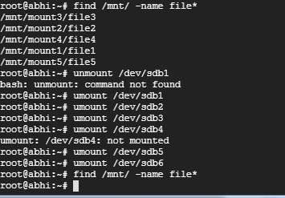

DELETE ALL PARTITIONS:

fdisk /dev/sdb

Press “p” and give partition number you want to delete.

**Part 2:**

Install LVM: # apt-get install lvm*

Use lvmdiskscan to list all blocks that lvm can see.

Mark the storage devices as LVM physical volumes

# pvcreate /dev/sdb1

### Create New Volume Group from Physical Volumes

vgcreate group1 /dev/sdb1

### Creating a Logical Volume by Specifying Size (1G)

lvcreate -L 1G -n test group1

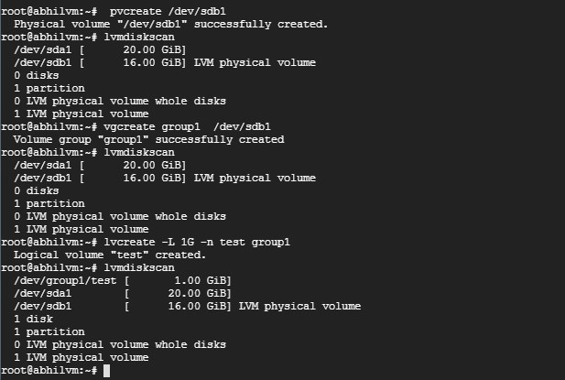

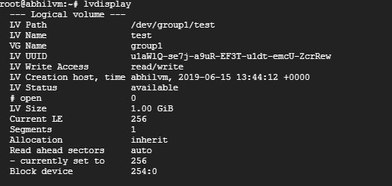

Increase size by 500MB:

lvextend -L +10M /dev/group1/test

To resize run

e2fsck -f /dev/group1/test

resize2fs /dev/group1/test

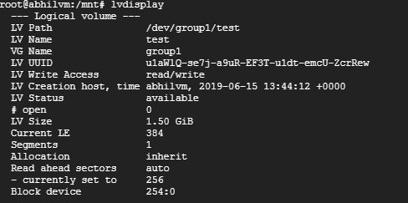

To reduce:

lvreduce -L +1G /dev/group1/test

